Government of Nepal
NATIONAL EDUCATION BOARD
Secondary Education Examination , Grade – 10
GRADE - SHEET
The Grade Secured by Sani Shrestha
Date of Birth 2058/05/12 (B.S)
Symbol No. 0492580
IN THE ANNUAL SEE EXAMINATION , GRADE – 10 OF 2078 ( B.S )
ARE GIVEN BELOW :
Students Details
Symbol No. |  |  | 2551652
Date of Birth |  |  | 18/01/2058
Grade Details
 | Subjects | Credit  Hour |  | Obtains Grade |  | Final Grade | Grade Point
 |  |  |  | TH | PR
1. | Comp.English | 4 |  | A+ | A+ | A+ | 4.0
2. | Comp.Nepali | 4 |  | C+ |  | C+ | 2.4
3. | Comp.Mathematics | 4 |  | C |  | C | 2.0
4. | Comp.Science | 4 |  | B | A+ | B+ | 3.2
5. | Comp.Social Studies | 4 |  | B |  | B | 2.8
6. | Opt.I Economics | 4 |  | A |  | A | 3.6
7. | Account | 4 |  | C+ | A+ | C+ | 2.4
8. | Comp.Health,Pop,&Env Edu | 4 |  | C | A+ | B | 2.8
Grande Point Average (GPA) : 2.90
Checked By:
NEB , Sanothimi , Bhaktapur , Nepal
Date of Issue : 2079/03/02

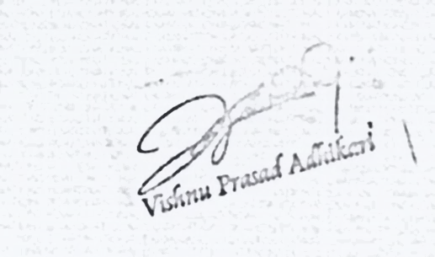
Controller of Examination
Controller of Examination

